Report into the death of Connor Sparrowhawk
What happened
In July 2013 a man with learning disabilities died in one of our inpatient units in Oxfordshire. He was 18 years old.
The young man was called Connor Sparrowhawk.
He was found unconscious in the bath. He was taken to the local hospital where he died.
Connor had drowned in the bath. We think he had an epileptic seizure.
The investigation
 | We asked an external company to investigate how Connor died to see what went wrong.  The investigation looked at all the facts.  They looked at how we cared for Connor.  They looked at his care records and notes.  They spoke to staff and Connor’s family.

What the investigation found
   | After the investigation, a report was written. The report is 116 pages long.  The report found that Connor’s death was preventable.  There are two areas where we should have cared for Connor better.  - We did not meet all of Connor’s needs. We did not put the right plans in place to keep him safe. Connor could have been checked more often when he was in the bath.  - The care Connor received could have been better. We needed to be better at working together to make sure Connor got the right care.
What happened after Connor died
  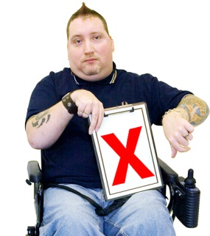 | After Connor died the unit was inspected by the Care Quality Commission.  The Care Quality Commission found that the unit did not meet the required standards.  We closed the units to new patients and made a plan to put things right.
What is happening now
   | We have new external leaders.  We are giving our staff more training especially in epilepsy care.  A nurse has looked at all the epilepsy care plans.  We are using a patient feedback questionnaire to hear patient views so we can put things right.
We are sorry
We are deeply sorry that Connor died whilst in our care.
We are sorry that we didn’t keep him safe.
We are sorry to Connor’s family and friends.
We are doing all we can to learn from this, to make sure it doesn’t happen again.
Comments and concerns
 | If you are concerned about anything you have seen or read you can speak to someone you trust.  This may be a family member, a friend or someone who works with you, a carer or staff member.
Key words
In this document the key words are highlighted in red. Here is an explanation of the key words to help you understand this document.
Inpatient units – an inpatient unit is a hospital where people go to be looked after when they are unwell. They live at the unit until they are well. They are cared for by staff, take part in activities and sleep at the unit. Friends and family can visit people while they are in the unit.
Investigation – an investigation is where people look at the facts to see what happened in a situation. This investigation looked at the care that Connor received to see whether anything could be done differently which would have meant Connor didn’t die.
Report – a report is a document that is written which explains what has happened. This report explained all the details from the investigation to tell us what happened.
Epilepsy – Epilepsy is a medical condition. In the UK, there are over 600,000 people with epilepsy. It is caused by changes in the electrical activity in the brain.
Preventable – when something is preventable it means that things could have been done which would mean that the event wouldn’t have happened.
Care Quality Commission – The Care Quality Commission is an organisation that inspects health care facilities to make sure they are up to standard.
Required standards – the required standards of an inpatient facility are set by the Care Quality Commission.

